> Data <- read.csv("E:/Data Science Asignments/Multilinear Regression/ToyotaCorolla.csv")

>

> Corolla<-Data[c("Price","Age_08_04","KM","HP","cc","Doors","Gears","Quarterly_Tax","Weight")]

>

> attach(Corolla)

The following objects are masked from Corolla (pos = 3):

Age_08_04, cc, Doors, Gears, HP, KM, Price, Quarterly_Tax, Weight

>

> # First Moment Business Decision

> summary(Corolla)

Price Age_08_04 KM HP cc

Min. : 4350 Min. : 1.00 Min. : 1 Min. : 69.0 Min. : 1300

1st Qu.: 8450 1st Qu.:44.00 1st Qu.: 43000 1st Qu.: 90.0 1st Qu.: 1400

Median : 9900 Median :61.00 Median : 63390 Median :110.0 Median : 1600

Mean :10731 Mean :55.95 Mean : 68533 Mean :101.5 Mean : 1577

3rd Qu.:11950 3rd Qu.:70.00 3rd Qu.: 87021 3rd Qu.:110.0 3rd Qu.: 1600

Max. :32500 Max. :80.00 Max. :243000 Max. :192.0 Max. :16000

Doors Gears Quarterly_Tax Weight

Min. :2.000 Min. :3.000 Min. : 19.00 Min. :1000

1st Qu.:3.000 1st Qu.:5.000 1st Qu.: 69.00 1st Qu.:1040

Median :4.000 Median :5.000 Median : 85.00 Median :1070

Mean :4.033 Mean :5.026 Mean : 87.12 Mean :1072

3rd Qu.:5.000 3rd Qu.:5.000 3rd Qu.: 85.00 3rd Qu.:1085

Max. :5.000 Max. :6.000 Max. :283.00 Max. :1615

> # Second Moment Business Decision

> sd(Price)

[1] 3626.965

> sd(Age_08_04)

[1] 18.59999

> sd(KM)

[1] 37506.45

> sd(HP)

[1] 14.98108

> sd(cc)

[1] 424.3868

> var(HP)

[1] 224.4327

> var(cc)

[1] 180104.1

>

> var(Doors)

[1] 0.9075927

>

> var(Gears)

[1] 0.03553619

>

> var(Quarterly_Tax)

[1] 1691.563

>

> var(Weight)

[1] 2771.088

>

> skewness(Price)

[1] 1.700327

>

> skewness(Age_08_04)

[1] -0.8249756

>

> skewness(KM)

[1] 1.013791

>

> skewness(HP)

[1] 0.9538397

>

> skewness(cc)

[1] 27.37451

>

> skewness(Doors)

[1] -0.07623547

>

> skewness(Gears)

[1] 2.27919

>

> skewness(Quarterly_Tax)

[1] 1.98967

>

> skewness(Weight)

[1] 3.102148

>

> kurtosis(Price)

[1] 3.711247

>

> kurtosis(Age_08_04)

[1] -0.08460596

>

> kurtosis(KM)

[1] 1.668511

>

> kurtosis(HP)

[1] 8.78509

>

> kurtosis(cc)

[1] 926.1741

>

> kurtosis(Doors)

[1] -1.873989

>

> kurtosis(Gears)

[1] 37.51167

> kurtosis(Quarterly_Tax)

[1] 4.269083

>

> kurtosis(Weight)

[1] 19.26034

>

> plot(Age_08_04, Price) ## Newr the Car more expensive it is.

>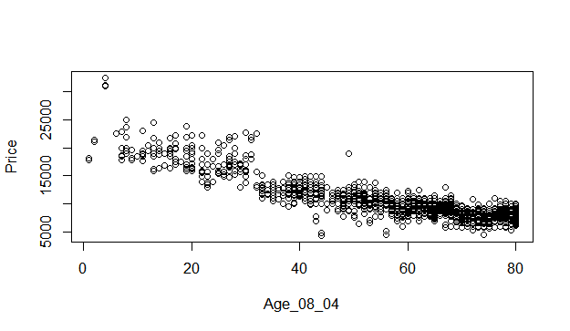

> plot(KM, Price) ## The more miles a car has the cheaper it is

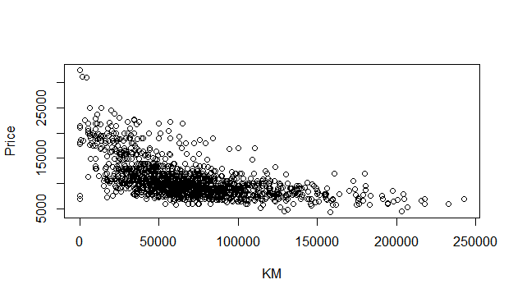

> plot(HP, Price) ## More horsepower the more expensive.

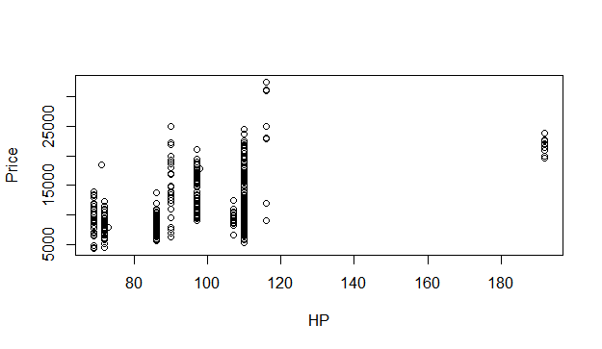 vc

Plot(cc,price)##

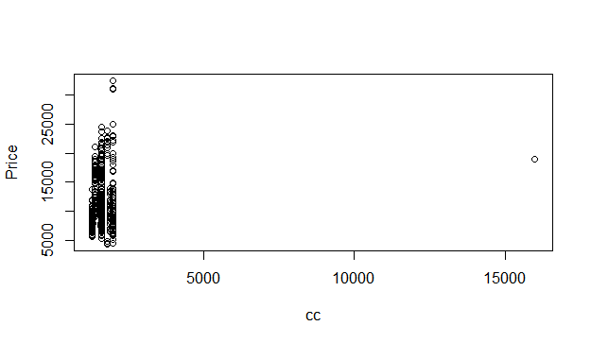

plot(Doors, Price)

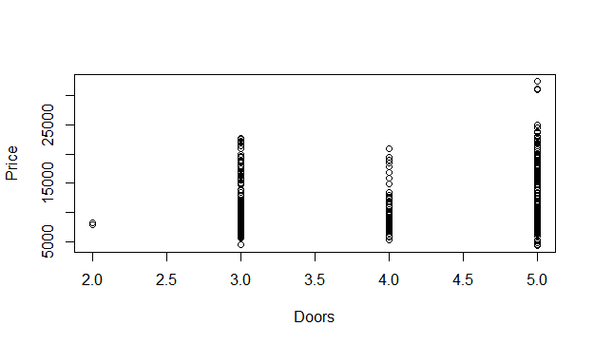

plot(Gears, Price)

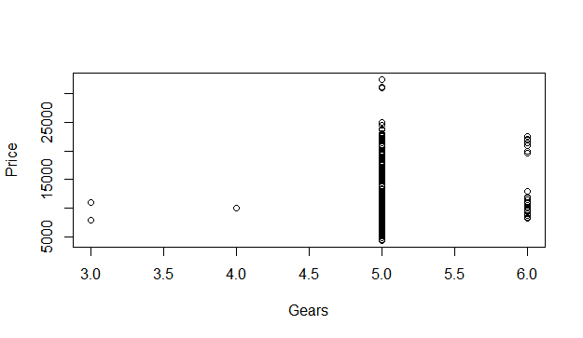

plot(Quarterly_Tax, Price)

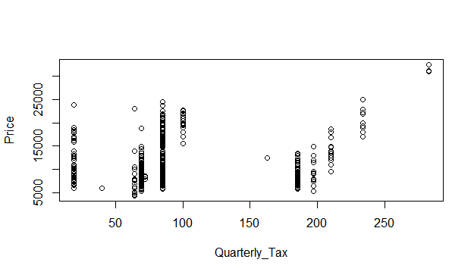

plot(Weight, Price)

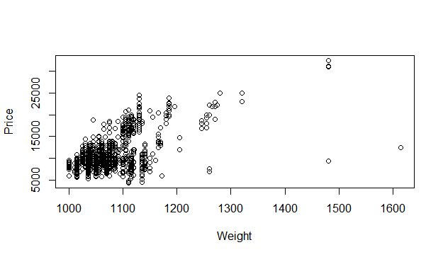

> # Cars of Fuels types

> summary(Data$Fuel_Type)

CNG Diesel Petrol

17 155 1264 #summary(Data$Model)

> summary(Data$Color)

Beige Black Blue Green Grey Red Silver Violet White Yellow

3 191 283 220 301 278 122 4 31 3

# Find Correlation between input and output

pairs(Corolla)

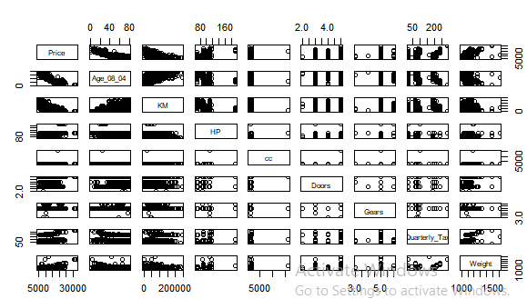

# Correlation Coefficient matrix - Strength & Direction of Correlation

cor(Corolla)

> cor(Corolla)

Price Age_08_04 KM HP cc

Price 1.00000000 -0.876590497 -0.56996016 0.31498983 0.12638920

Age_08_04 -0.87659050 1.000000000 0.50567218 -0.15662202 -0.09808374

KM -0.56996016 0.505672180 1.00000000 -0.33353795 0.10268289

HP 0.31498983 -0.156622020 -0.33353795 1.00000000 0.03585580

cc 0.12638920 -0.098083739 0.10268289 0.03585580 1.00000000

Doors 0.18532555 -0.148359215 -0.03619661 0.09242450 0.07990330

Gears 0.06310386 -0.005363947 0.01502333 0.20947715 0.01462935

Quarterly_Tax 0.21919691 -0.198430508 0.27816470 -0.29843172 0.30699580

Weight 0.58119759 -0.470253184 -0.02859846 0.08961406 0.33563740

##Pure Correlation b/n the varibles

> library(corpcor)

> cor2pcor(cor(Corolla))

[,1] [,2] [,3] [,4] [,5] [,6]

[1,] 1.000000000 -0.776238352 -0.402745405 0.28521314 -0.03556185 -0.001069746

[2,] -0.776238352 1.000000000 0.002383081 0.24531845 -0.02014628 -0.002800916

[3,] -0.402745405 0.002383081 1.000000000 -0.06039653 0.05108725 0.026724172

[4,] 0.285213137 0.245318454 -0.060396533 1.00000000 0.09871851 0.068175272

[5,] -0.035561846 -0.020146283 0.051087249 0.09871851 1.00000000 -0.016060377

[6,] -0.001069746 -0.002800916 0.026724172 0.06817527 -0.01606038 1.000000000

[7,] 0.079586710 0.051074865 0.100506331 0.20769268 -0.01198838 -0.189249333

[8,] 0.079548117 0.015830863 0.261673195 -0.38254954 0.12380803 -0.074825415

[9,] 0.387523482 0.094746528 0.187502181 0.12427899 0.16043171 0.231960007

[,7] [,8] [,9]

[1,] 0.07958671 0.07954812 0.38752348

[2,] 0.05107486 0.01583086 0.09474653

[3,] 0.10050633 0.26167319 0.18750218

[4,] 0.20769268 -0.38254954 0.12427899

[5,] -0.01198838 0.12380803 0.16043171

[6,] -0.18924933 -0.07482541 0.23196001

[7,] 1.00000000 0.03732241 -0.02325832

[8,] 0.03732241 1.00000000 0.51026027

[9,] -0.02325832 0.51026027 1.00000000

## Building linear regression model

> model <- lm(Price ~ ., data = Corolla)

> summary(model)

Call:

lm(formula = Price ~ ., data = Corolla)

Residuals:

Min 1Q Median 3Q Max

-9366.4 -793.3 -21.3 799.7 6444.0

Coefficients:

Estimate Std. Error t value Pr(>|t|)

(Intercept) -5.573e+03 1.411e+03 -3.949 8.24e-05 ***

Age_08_04 -1.217e+02 2.616e+00 -46.512 < 2e-16 ***

KM -2.082e-02 1.252e-03 -16.622 < 2e-16 ***

HP 3.168e+01 2.818e+00 11.241 < 2e-16 ***

cc -1.211e-01 9.009e-02 -1.344 0.17909

Doors -1.617e+00 4.001e+01 -0.040 0.96777

Gears 5.943e+02 1.971e+02 3.016 0.00261 **

Quarterly_Tax 3.949e+00 1.310e+00 3.015 0.00262 **

Weight 1.696e+01 1.068e+00 15.880 < 2e-16 ***

---

Signif. codes: 0 ‘***’ 0.001 ‘**’ 0.01 ‘*’ 0.05 ‘.’ 0.1 ‘ ’ 1

Residual standard error: 1342 on 1427 degrees of freedom

Multiple R-squared: 0.8638, Adjusted R-squared: 0.863

F-statistic: 1131 on 8 and 1427 DF, p-value: < 2.2e-16

# cc and Doors are influence to each other, predict the model based on individual records

> model.carcc <- lm(Price ~ cc)

> summary(model.carcc) # Its significat to output

Call:

lm(formula = Price ~ cc)

Residuals:

Min 1Q Median 3Q Max

-7360.2 -2305.8 -855.8 1194.2 21312.1

Coefficients:

Estimate Std. Error t value Pr(>|t|)

(Intercept) 9027.5548 365.5755 24.694 < 2e-16 ***

cc 1.0802 0.2239 4.825 1.55e-06 ***

---

Signif. codes: 0 ‘***’ 0.001 ‘**’ 0.01 ‘*’ 0.05 ‘.’ 0.1 ‘ ’ 1

Residual standard error: 3599 on 1434 degrees of freedom

Multiple R-squared: 0.01597, Adjusted R-squared: 0.01529

F-statistic: 23.28 on 1 and 1434 DF, p-value: 1.551e-06

> model.cardoor <- lm(Price ~ Doors)

> summary(model.cardoor) # It's also significatnt

Call:

lm(formula = Price ~ Doors)

Residuals:

Min 1Q Median 3Q Max

-7062.8 -2251.7 -915.3 958.0 21087.2

Coefficients:

Estimate Std. Error t value Pr(>|t|)

(Intercept) 7885.01 409.44 19.258 < 2e-16 ***

Doors 705.56 98.79 7.142 1.46e-12 ***

---

Signif. codes: 0 ‘***’ 0.001 ‘**’ 0.01 ‘*’ 0.05 ‘.’ 0.1 ‘ ’ 1

Residual standard error: 3565 on 1434 degrees of freedom

Multiple R-squared: 0.03435, Adjusted R-squared: 0.03367

F-statistic: 51 on 1 and 1434 DF, p-value: 1.461e-12

> ## Build model with cc and Doors

> model.car <- lm(Price ~ cc + Doors)

> summary(model.car) # Both are significant to each other

Call:

lm(formula = Price ~ cc + Doors)

Residuals:

Min 1Q Median 3Q Max

-7243.9 -2273.6 -821.3 1054.4 20714.1

Coefficients:

Estimate Std. Error t value Pr(>|t|)

(Intercept) 6509.4211 515.7732 12.621 < 2e-16 ***

cc 0.9597 0.2211 4.340 1.52e-05 ***

Doors 671.3973 98.5009 6.816 1.37e-11 ***

---

Signif. codes: 0 ‘***’ 0.001 ‘**’ 0.01 ‘*’ 0.05 ‘.’ 0.1 ‘ ’ 1

Residual standard error: 3543 on 1433 degrees of freedom

Multiple R-squared: 0.04688, Adjusted R-squared: 0.04555

F-statistic: 35.24 on 2 and 1433 DF, p-value: 1.15e-15

# Find out the influencial record

> influence.measures(model.car)

Influence measures of

lm(formula = Price ~ cc + Doors) :

dfb.1_ dfb.cc dfb.Dors dffit cov.r cook.d hat inf

1 0.00790 0.024816 -0.0267 0.0418 1.003 5.83e-04 0.00234

2 0.00855 0.026847 -0.0288 0.0452 1.003 6.83e-04 0.00234

3 0.00906 0.028472 -0.0306 0.0480 1.002 7.68e-04 0.00234

4 0.01165 0.036598 -0.0393 0.0617 1.001 1.27e-03 0.00234

5 0.00855 0.026847 -0.0288 0.0452 1.003 6.83e-04 0.00234

6 0.00648 0.020349 -0.0219 0.0343 1.003 3.92e-04 0.00234

7 0.01670 0.052465 -0.0564 0.0884 0.997 2.60e-03 0.00234

8 0.02111 0.066324 -0.0713 0.1118 0.993 4.15e-03 0.00234 *

9 0.05361 0.051749 -0.0952 0.1346 0.983 6.00e-03 0.00178 *

10 0.00955 0.016530 -0.0223 0.0331 1.003 3.65e-04 0.00202

11 0.05098 0.049202 -0.0905 0.1280 0.985 5.43e-03 0.00178 *

12 0.04618 0.044578 -0.0820 0.1159 0.988 4.46e-03 0.00178 *

13 0.04451 0.042961 -0.0790 0.1117 0.989 4.14e-03 0.00178 *

14 0.05361 0.051749 -0.0952 0.1346 0.983 6.00e-03 0.00178 *

15 0.05842 0.056386 -0.1037 0.1466 0.979 7.11e-03 0.00178 *

16 0.05601 0.054067 -0.0995 0.1406 0.981 6.54e-03 0.00178 *

17 0.05962 0.057547 -0.1059 0.1497 0.978 7.41e-03 0.00178 *

18 0.05466 0.008352 -0.0644 0.0874 0.993 2.54e-03 0.00153 *

19 0.04632 0.007079 -0.0546 0.0740 0.996 1.82e-03 0.00153

20 0.04771 0.007291 -0.0562 0.0763 0.996 1.94e-03 0.00153

21 0.04077 0.006230 -0.0481 0.0652 0.998 1.41e-03 0.00153

22 0.04771 0.007291 -0.0562 0.0763 0.996 1.94e-03 0.00153

23 0.04077 0.006230 -0.0481 0.0652 0.998 1.41e-03 0.00153

24 0.04771 0.007291 -0.0562 0.0763 0.996 1.94e-03 0.00153

25 0.04285 0.006548 -0.0505 0.0685 0.997 1.56e-03 0.00153

26 0.04077 0.006230 -0.0481 0.0652 0.998 1.41e-03 0.00153

27 0.05150 0.007869 -0.0607 0.0823 0.994 2.25e-03 0.00153

28 0.03939 0.006019 -0.0464 0.0630 0.998 1.32e-03 0.00153

29 0.04771 0.007291 -0.0562 0.0763 0.996 1.94e-03 0.00153

30 0.05466 0.008352 -0.0644 0.0874 0.993 2.54e-03 0.00153 *

31 0.02801 -0.007616 -0.0243 0.0348 1.002 4.03e-04 0.00159

32 0.05348 -0.014544 -0.0463 0.0664 0.998 1.47e-03 0.00159

33 0.05530 -0.015039 -0.0479 0.0687 0.998 1.57e-03 0.00159

34 0.04620 -0.012563 -0.0400 0.0574 0.999 1.10e-03 0.00159

35 0.05120 -0.013924 -0.0444 0.0636 0.998 1.35e-03 0.00159

36 0.05348 -0.014544 -0.0463 0.0664 0.998 1.47e-03 0.00159

37 0.05530 -0.015039 -0.0479 0.0687 0.998 1.57e-03 0.00159

38 0.04620 -0.012563 -0.0400 0.0574 0.999 1.10e-03 0.00159

39 0.05348 -0.014544 -0.0463 0.0664 0.998 1.47e-03 0.00159

40 0.04438 -0.012068 -0.0384 0.0551 1.000 1.01e-03 0.00159

41 0.03710 -0.010089 -0.0321 0.0461 1.001 7.07e-04 0.00159

42 0.06259 -0.017022 -0.0542 0.0777 0.996 2.01e-03 0.00159

43 0.03710 -0.010089 -0.0321 0.0461 1.001 7.07e-04 0.00159

44 -0.04483 0.035439 0.0362 0.0654 1.000 1.42e-03 0.00200

45 -0.04483 0.035439 0.0362 0.0654 1.000 1.42e-03 0.00200

46 -0.06267 0.049542 0.0506 0.0914 0.995 2.78e-03 0.00200

47 -0.05353 0.042315 0.0432 0.0781 0.998 2.03e-03 0.00200

48 -0.00997 -0.017108 0.0360 0.0517 1.000 8.91e-04 0.00159

49 -0.05353 0.042315 0.0432 0.0781 0.998 2.03e-03 0.00200

50 -0.06756 0.034567 0.0756 0.1156 0.986 4.43e-03 0.00155 *

51 -0.05353 0.042315 0.0432 0.0781 0.998 2.03e-03 0.00200

52 -0.00986 -0.016922 0.0356 0.0511 1.000 8.71e-04 0.00159

53 -0.03954 -0.001810 0.0689 0.0969 0.990 3.12e-03 0.00141 *

54 -0.06756 0.034567 0.0756 0.1156 0.986 4.43e-03 0.00155 *

55 -0.01778 -0.000814 0.0310 0.0436 1.001 6.32e-04 0.00141

56 -0.00801 -0.000367 0.0140 0.0196 1.003 1.29e-04 0.00141

57 -0.00877 -0.015056 0.0317 0.0455 1.001 6.90e-04 0.00159

58 -0.00877 -0.015056 0.0317 0.0455 1.001 6.90e-04 0.00159

59 -0.03278 -0.001501 0.0571 0.0803 0.994 2.15e-03 0.00141

60 -0.01995 -0.000913 0.0348 0.0489 1.000 7.96e-04 0.00141

61 -0.00812 -0.013937 0.0293 0.0421 1.001 5.91e-04 0.00159

62 -0.02212 -0.001013 0.0386 0.0542 0.999 9.79e-04 0.00141

63 -0.03191 -0.001461 0.0556 0.0782 0.994 2.03e-03 0.00141

64 -0.02843 -0.001301 0.0496 0.0697 0.996 1.61e-03 0.00141

65 -0.01465 -0.025139 0.0529 0.0760 0.996 1.92e-03 0.00159

66 -0.02408 -0.001102 0.0420 0.0590 0.998 1.16e-03 0.00141

67 -0.03278 -0.001501 0.0571 0.0803 0.994 2.15e-03 0.00141

68 -0.00812 -0.013937 0.0293 0.0421 1.001 5.91e-04 0.00159

69 -0.09105 0.071976 0.0735 0.1328 0.986 5.84e-03 0.00200 *

70 -0.01029 -0.017668 0.0372 0.0534 1.000 9.50e-04 0.00159

71 -0.01029 -0.017668 0.0372 0.0534 1.000 9.50e-04 0.00159

72 -0.00387 -0.006650 0.0140 0.0201 1.003 1.35e-04 0.00159

73 -0.03263 -0.001768 0.0572 0.0803 0.994 2.15e-03 0.00141

74 -0.00986 -0.016922 0.0356 0.0511 1.000 8.71e-04 0.00159

75 -0.03714 -0.001700 0.0647 0.0910 0.991 2.75e-03 0.00141 *

76 -0.02408 -0.001102 0.0420 0.0590 0.998 1.16e-03 0.00141

77 -0.03191 -0.001461 0.0556 0.0782 0.994 2.03e-03 0.00141

78 -0.03060 -0.001401 0.0533 0.0750 0.995 1.87e-03 0.00141

79 -0.02384 -0.001091 0.0416 0.0584 0.998 1.14e-03 0.00141

80 -0.00801 -0.013751 0.0289 0.0416 1.001 5.76e-04 0.00159

81 5.25011 -8.306571 0.4167 -8.3139 5.034 2.28e+01 0.80763 *

82 -0.02538 -0.001162 0.0442 0.0622 0.998 1.29e-03 0.00141

83 -0.00921 -0.015802 0.0333 0.0478 1.001 7.60e-04 0.00159

84 -0.02843 -0.001301 0.0496 0.0697 0.996 1.61e-03 0.00141

85 -0.01182 -0.020281 0.0427 0.0613 0.999 1.25e-03 0.00159

86 -0.02625 -0.001202 0.0458 0.0643 0.997 1.38e-03 0.00141

87 -0.00801 -0.013751 0.0289 0.0416 1.001 5.76e-04 0.00159

88 0.01942 0.061021 -0.0656 0.1029 0.995 3.52e-03 0.00234

89 0.05530 -0.015039 -0.0479 0.0687 0.998 1.57e-03 0.00159

90 0.02984 0.093736 -0.1007 0.1580 0.982 8.26e-03 0.00234 *

91 0.05986 -0.016278 -0.0519 0.0743 0.996 1.84e-03 0.00159

92 0.03062 0.096198 -0.1034 0.1621 0.981 8.70e-03 0.00234 *

93 0.02515 0.076549 -0.0831 0.1299 0.989 5.60e-03 0.00232 *

94 0.05530 -0.015039 -0.0479 0.0687 0.998 1.57e-03 0.00159

95 0.06127 0.009362 -0.0722 0.0979 0.991 3.19e-03 0.00153 *

96 0.02515 0.076549 -0.0831 0.1299 0.989 5.60e-03 0.00232 *

97 0.05530 -0.015039 -0.0479 0.0687 0.998 1.57e-03 0.00159

98 0.05530 -0.015039 -0.0479 0.0687 0.998 1.57e-03 0.00159

99 0.06022 0.009202 -0.0710 0.0963 0.991 3.08e-03 0.00153 *

100 0.06898 -0.018758 -0.0598 0.0856 0.994 2.44e-03 0.00159

101 0.06189 0.009458 -0.0729 0.0989 0.990 3.25e-03 0.00153 *

102 0.05804 -0.015782 -0.0503 0.0721 0.997 1.73e-03 0.00159

103 0.07857 -0.021366 -0.0681 0.0976 0.991 3.16e-03 0.00159 *

104 0.05848 0.008937 -0.0689 0.0935 0.992 2.90e-03 0.00153 *

105 0.06510 0.009947 -0.0767 0.1041 0.989 3.59e-03 0.00153 *

106 0.06442 -0.017518 -0.0558 0.0800 0.995 2.13e-03 0.00159

107 0.06057 0.009256 -0.0714 0.0968 0.991 3.11e-03 0.00153 *

108 0.06898 -0.018758 -0.0598 0.0856 0.994 2.44e-03 0.00159

109 0.05466 0.008352 -0.0644 0.0874 0.993 2.54e-03 0.00153 *

110 -0.18187 0.143773 0.1467 0.2652 0.934 2.29e-02 0.00200 *

111 -0.16841 0.133135 0.1359 0.2456 0.943 1.97e-02 0.00200 *

112 -0.17088 0.135081 0.1379 0.2492 0.942 2.03e-02 0.00200 *

113 -0.11475 0.090710 0.0926 0.1673 0.975 9.25e-03 0.00200 *

114 -0.11475 0.090710 0.0926 0.1673 0.975 9.25e-03 0.00200 *

115 -0.09718 0.076824 0.0784 0.1417 0.983 6.65e-03 0.00200 *

116 -0.11510 0.090989 0.0929 0.1678 0.975 9.30e-03 0.00200 *

117 -0.08842 0.069901 0.0713 0.1289 0.987 5.51e-03 0.00200 *

118 0.05431 0.008299 -0.0640 0.0868 0.993 2.51e-03 0.00153 *

119 -0.06485 0.051264 0.0523 0.0946 0.995 2.97e-03 0.00200

120 -0.09105 0.071976 0.0735 0.1328 0.986 5.84e-03 0.00200 *

121 -0.03278 -0.001501 0.0571 0.0803 0.994 2.15e-03 0.00141

122 -0.07095 0.056089 0.0572 0.1035 0.993 3.56e-03 0.00200 *

123 -0.02147 -0.000983 0.0374 0.0526 0.999 9.22e-04 0.00141

124 -0.03278 -0.001501 0.0571 0.0803 0.994 2.15e-03 0.00141

125 -0.02408 -0.001102 0.0420 0.0590 0.998 1.16e-03 0.00141

[ reached 'max' / getOption("max.print") -- omitted 1311 rows ]

>